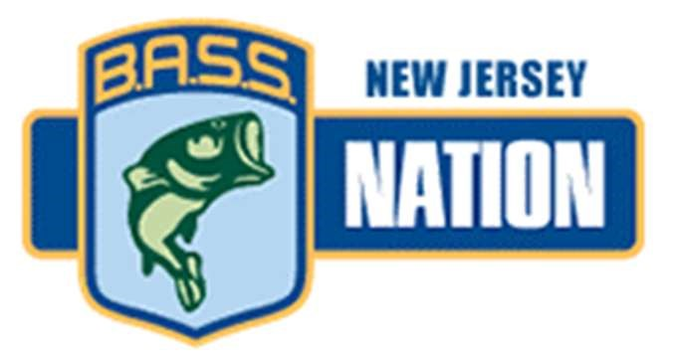

NJ B.A.S.S. NATION 2022 TOURNAMENT
MANUAL

TOURNAMENT TRAIL COMMITTEE:

TOURNAMENT DIRECTOR – BOB BRENNAN
732- 604 - 8948

PRESIDENT – RANDY BARAN
732 – 887- 7650

VICE PRESIDENT – BILL TYGER
732 – 668 - 3445

SECRECTARY – DAVE HAAS
609 – 377 - 0767

TREASURER – JESSE MAGEE
856 – 404 - 4218

** 2022 STATE TEAM QUALIFYING FORMAT**

POINTS TRAIL:
TOP 5 BOATERS AND TOP 5 RIDERS
QUAILIFY FOR THE 2023 STATE TEAM

STATE TEAM QUALIFIER:
TOP 5 BOATERS AND TOP 5 RIDERS
QUAILIFY FOR THE 2023 STATE TEAM

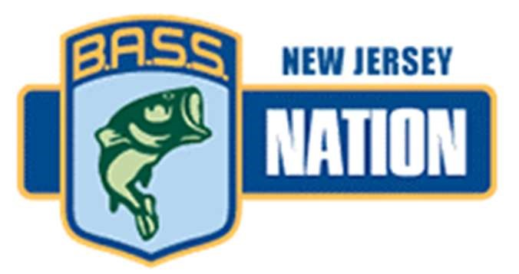

NJ BASS NATION 2022 TOURNAMENT SCHEDULE

Date Location Facility

Sun April 24th North East Flats Anchor Marina

Sat May 14th Candlewood Lake Latins

Sun July 17th North East Flats Anchor Marina

4th, 5th, 6th of Aug Upper Champlain Pt Au Roche

Sun Oct 2nd Hudson River Dutchman’s Landing

Sun Nov 13th Delaware River Gloucester Ramp

2022 SEASON WILL INCLUDE ONE DROP TOURNAMENT.
THERE WILL BE NO OFF-LIMITS TIME FRAME FOR ANY POINTS
EVENTS.

STATE TEAM QUALIFIER WILL BE A NON-POINTS EVENT.

STQ IS A 3 DAY TOURNAMENT EVENT AND WILL FEATURE
A PAYOUT. (BASED ON NUMBER OF ENTRIES)

ANY BOATER OR NON-BOATER WHO IS A CURRENT MEMBER OF THE NJ B.A.S.S. NATION IS ELIGIBLE TO PARTICIPATE IN THE STQ.
TOURNAMENT LOGISTICS AND PROCEDURES

REGISTRATION

TOURNAMENT REGISTRATION WILL BE VIA THE NJBN WEB SITE
(AS NORMAL)

TOURNAMENT REGISTRATION WILL END ON FRIDAY
AT 11:59 PM ONE WEEK BEFORE THE TOURNAMENT
(STQ WILL BE TWO (2) WEEKS BEFORE)

ALL ENTRY FEES MUST BE PAID BY 11:59 PM ON THE SAME DAY REGISTRATION ENDS, FOR THE ANGLER TO BE ELIGIBLE TO FISH.

AFTER 11:59 OF THE FINAL DAY OF REGISTRATION,
THERE WILL BE NO REFUNDS. TOURNAMENT PAYOUT WILL BE BASED ON THAT NUMBER, AND CHECKS WILL BE WRITTEN AT THE TOURNAMENT DRAW.

TOURNAMENT DRAW WILL TAKE PLACE ON SATURDAY,
THE DAY AFTER REGISTRATION ENDS. (U.O.N.)

YOUR PAIRINGS, BOAT CHECK AND LAUNCH TIMES, FLIGHTS AND FLIGHT START TIMES, CHECK IN AND WEIGH IN WILL BE ACCESSED TWO WAYS.
* VIA THE WEBSITE. (AS NORMAL)
* A SHEET WILL BE HANDED TO YOU AT BOAT CHECK (ON LAND)

WEIGH IN- YOU WILL BE CALLED BY BOAT # TO WEIGH IN.
ALL WILL BE IN WATER WEIGH INNS

TOURNAMENT DAY PROCEDURES

- AS YOU ARRIVE TO THE RAMP, A RANDOMLY CHOSEN MEMBER
WILL GREET YOU AND HAND YOU A SLIP OF PAPER CONTAINING TOURNAMENT INFORMATION. THAT PAPER WILL TAKE PRECEDANCE TO ALL PRIOR INFORMATION. THERE MAY BE NO CHANGE FROM PAST INFORMATION, HOWEVER, IT WIL BE IMPORTANT TO REVIEW THE INFORMATION.

- ALL BOATS MUST BE IN THE WATER AND READY TO START 15 MINUTES BEFORE OFFICIAL START TIME. IF NOT, YOU WILL GO TO THE BACK OF THE LINE, AND STILL CHECK IN AT YOUR DESIGNATED TIME.

- BOAT #1 WILL LEAVE 10 MINUTES BEFORE THE WHOLE FIELD. (CONDITIONS PERMITTING). THE LAST BOAT
NUMBER WILL BE THE START BOAT. BOATS 2 THRU 5 WILL HELP SET UP THE WEIGH IN AND THE LAST 4 BOAT NUMBERS WILL HELP BREAK DOWN THE WEIGH IN. NO EXCUSES!

- AS YOU ARRIVE AT THE RAMP TO RECEIVE YOUR TOURNMENT INFO SLIP. YOUR BOATS LIVEWELLS WILL BE CHECKED. HAVE THEM OPEN AND READY.

- AT THE START, ALL BOATS WILL LINE UP IN NUMBER
ORDER AND PASS THE START BOAT. HAVE YOUR
LIVEWELLS OPEN AND RUNNING AND LIGHTS IN AND ON. AS YOU PASS THE START BOAT, YOU WILL RECEIVE YOUR
BOAT NUMBER KEY FOB. AS SOON AS YOU GET 25 YARDS
PAST THE START BOAT, YOU MUST DEMONSTRATE YOUR KILL SWITCH TO YOUR PARTNER. IF YOU DO NOT HAVE A PARTNER, DEMONSTRATE IT TO YOURSELF.

2023 STATE TEAM - QUALIFING IN 2022

5 BOATERS FROM POINTS TRAIL EVENTS

5 RIDERS FROM POINTS TRAIL EVENTS

5 BOATERS FROM SQT

5 RIDERS FROM SQT

ALTERNATES:
ALL ALTERNATES COME FROM THE FINAL POINTS STANDINGS AND FROM THEIR RESPECTED DIVISIONS. (BOATERS REPLACE BOATERS AND RIDERS REPLACE RIDERS)

MUST DO TO QUALIFY FOR STATE TEAM
IN THE 2022 SEASON, ALL NJ B.A.S.S. NATION STATE TEAM QUALIFIERS MUST FISH A TOTAL OF THREE (3) REGULAR EVENTS TO BE A MEMBER OF THE 2023 NJ STATE TEAM.
This does not include the 2022 STQ!

All previous NJBN Rules and Regulations apply
towards the 2022 Season
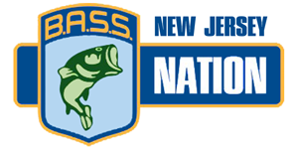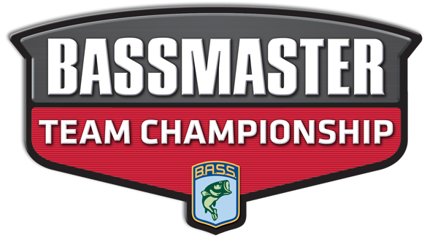
NJ BASS NATION TOURNAMENT TEAM TRAIL APP
BOATER RIDER
NAME |  | NAME
ADDRESS |  | ADDRESS
CITY |  | CITY
STATE ZIP |  | STATE ZIP
PHONE# |  | PHONE#
EMAIL |  | EMAIL

BOAT INFORMATION
MAKE MODEL
LENGTH
HP
REG #
INSURANCE
POLICY #

APP FEE: $100
PAYMENT METHOD :CASH/CHECK
PAYABLE TO:NJ BASS NATION

Tournament Application:
( ) Flats May 6 Anchor Marine ( ) Flats June 4 Anchor Marine
( ) Flats July 24 Anchor Marine ( ) Flats Aug 21 Anchor Marine

Name:______________________________________________
Boat Type___________ Engine Make_____________ Engine Size_______________
( )Tournament Fee $150.00 ( )Lunker $10
Total By signing below I have read ,understand and agree with all of the NJBN rules and regulations.
Boater Signature:______________________________________
Rider Signature:_______________________________________ Tournament Staff Boat #______________________________
Sign up on line at NJbassnation.org or Cash only at ramp

